Respondent Name: ________________

TARRANT COUNTY HOSPITAL DISTRICT d/b/a
JPS HEALTH NETWORK

RFP NO. 2026-0930

REQUEST FOR PROPOSALS
FOR CONSTRUCTION MANAGER AT-RISK FOR
PEC Ph. 2 CFA Allen Ave. Public Water Line
(One-Step Process)

Opening Date:

October 30, 2026
2:15 p.m.

TABLE OF CONTENTS

I. INTRODUCTION, OVERVIEW, AND GENERAL TERMS 2 – 7
II. GENERAL SUBMISSION REQUIREMENTS AND CONTRACT
TERMS AND CONDITIONS 7 – 13
III. EVALUATION AND SELECTION PROCESS 13 – 14
IV. EVALUATION CRITERIA 14– 16
V. PROPOSAL SUBMITTAL REQUIREMENTS 16 – 20
EXHIBIT A – RFP PROPOSAL CHECKLIST 20 – 21
EXHIBIT B – CONTRACT FORM (A133 – 2019 and A201-2017 (as modified) 22
EXHIBIT C –NOT USED 23
EXHIBIT D – BID FORM 24 – 30
EXHIBIT E –VERIFICATION FORM 31
EXHIBIT F – GOOD FAITH EVALUATION FORM 32 –33
EXHIBIT G – CONFLICT OF INTEREST QUESTIONNAIRE FORM 34 – 36
EXHIBIT H – RESPONDENT’S PROPOSED AMENDMENT FORM 37 - 38
EXHIBIT I – PROPOSAL SIGNATURE FORM 39
EXHIBIT J – SAMPLE FORMS 41
- Exhibit J-1 – FORM OF BID BOND
- Exhibit J-2 – FORM OF PAYMENT & PERFORMANCE BOND
- Exhibit J-3 – AIA G702 APPLICATION AND CERTIFICATION FOR PAYMENT
- Exhibit J-4 – AIA G703 CONTINUATION SHEET
- Exhibit J-5 – AIA G704 CERTIFICATE OF SUBSTANTIAL COMPLETION
- Exhibit J-6 – WAIVER AND RELEASE DOCUMENTS
- Exhibit J-7 – AIA G707 CONSENT OF SURETY TO FINAL PAYMENT
- Exhibit J-8 – AIA G707A CONSENT OF SURETY TO REDUCTION IN RETAINAGE

*NOTES: (1) EXHIBITS A, D, E, F, G, H AND I MUST BE COMPLETED AND RETURNED WITH THE PROPOSAL. This Table of Contents is intended as an aid to Respondents and not as a comprehensive listing of the bid package. Respondents are responsible for reading the entire bid package and complying with all requirements in this RFP and all documents referenced in this RFP and bid package.

I. INTRODUCTION, OVERVIEW, AND GENERAL TERMS
1.1 General Information. Pursuant to the provisions in Section 2269, Subchapter F of the Texas Government Code (“Chapter 2269”) and related laws, the Tarrant County Hospital District d/b/a JPS Health Network (the “District”) is seeking Proposals ("Proposals", individually a "Proposal") from interested parties (“Respondents”) qualified and experienced in providing Construction Manager At-Risk (“CMR”) services in connection with PEC Ph.2 CFA Allen Ave. Public Water Line(the “Project”), including but not limited to all preconstruction and construction services (the "Work"). The District will use the one-step selection process for this RFP and award, and will choose the Respondent who offers the best value to the District based on the Evaluation Criteria (as defined herein) specified in this RFP. Services required consist of (i) preconstruction services including, but not limited to constructability guidance, cost estimation, site evaluation, scheduling; (ii) provision of a Final Guaranteed Maximum Price (not to exceed the Initial Guaranteed Maximum Price included in the Proposal) following request from the District; and (iii) construction phase services consistent with the requirements of this RFP and the District as more fully described below in Section 1.2 and in this RFP. The applicable surveys, models, sketches, drawings, specifications, digital models, and other similar materials for construction of the Project (“Construction Documents”) have been prepared by Teague Nall and Perkins, Inc. (“Architect”). The Construction Documents may be obtained at no charge at District’s online “JPS Procurement System” located on the District’s Website at: https://jpshealth.gob2g.com/ (the “District’s RFP Portal”). All Respondents are responsible for obtaining and examining the Construction Documents prior to submission of a Proposal.
1.2 Project Scope and Project Requirements. The selected Respondent must collaborate with the District, and its Project Manager, Architect and engineers during the completion of the Construction Documents in order to provide preconstruction services including, but not limited to advising the District on proposed site use and improvements; selection and availability of materials and labor; constructability guidance; cost estimation; time requirements for procurement, installation and construction; use of temporary facilities; factors related to the cost of the Work including cost of alternative designs or materials, preliminary budgets and life-cycle data, resolution of conflicts in the proposed drawings and specifications as they evolve; methods of delivery and handling of materials, systems, and equipment; traffic, parking and materials and equipment storage in and around the site; safety issues and available precautions related to the Work; scheduling issues including phased construction and potential fast track scheduling; attendance at public meetings concerning the design, development, scheduling and Work of the Project; and any other matters necessary to accomplish the Project in accordance with the District’s schedule. Following the District’s acceptance of the Final GMP Proposal and execution of the Final GMP Amendment (or earlier in accordance with a Work package authorization), the selected Respondent shall provide all labor, materials, and equipment, coordination management, and supervision necessary for the construction of the following improvements: Procure and install a new 8” water line alongside Allen Ave., connecting to the existing 8” water line in May Street and the 18” water main in Jennings Avenue. The scope will also include the Fire and Domestic water services. The irrigation water service is not included in the scope.
The Respondent will need to be a pre-approved contractor with the City of Fort Worth prior to bid submission.
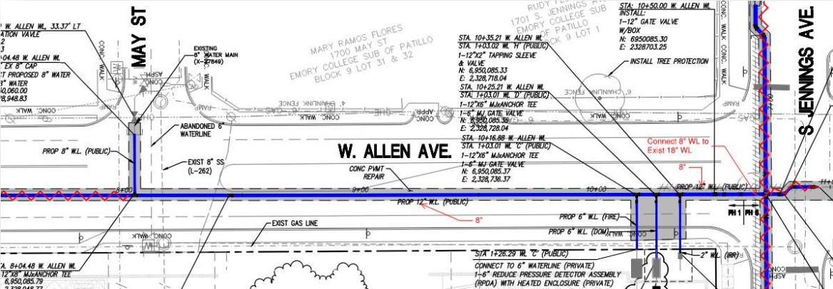
The selected Respondent will have overall responsibility for and shall provide complete Preconstruction Phase Services and Construction Services for the Project as set forth in the Contract Form (as defined below in Section 1.3).
The estimated Project Budget is: $350,000. The District requires the improvements to reach substantial completion by: 2/26/2027. The District requires the improvements to reach final completion by 3/28/2027.
1.3 Form of Contract. Any contract resulting from this RFP will be in the form of contract and all exhibits to the form of contract attached to this RFP as Exhibit B (the “Contract Form” or the “Contract”). Respondents must provide written confirmation of their acceptance of the Contract Form, inclusive of its respective exhibits and attachments in the Proposal. TO ENSURE THAT THIS RFP IS BASED ON FAIR COMPETITION, THE CONTRACT FORM AND THE TERMS AND CONDITIONS DESCRIBED IN THIS RFP AND Exhibit B ARE NON-NEGOTIABLE. Proposed changes, amendments, and/or revisions to the Contract Form may submitted, subject to the limitations and provisions of Section 2.19 and Exhibit H. Any and all proposed revisions shall be presented within Exhibit H - Respondents Proposed Revisions Form. After the Contract Award has been made, the District reserves the right to finalize the details of the agreement between the parties in the Contract with the selected Respondent.
1.4 Disadvantaged Business Enterprise Participation. The District maintains a policy of encouraging and engaging in business transactions with vendors who qualify and are certified under applicable law as Historically Underutilized Businesses (“HUBs”), Small Minority and Women Owned Business Enterprises (“SMWBEs”), and Individuals with Disabilities and Service-Disabled Veterans Owned Business Enterprises (“DOBEs”). HUBs, SMWBEs, and DOBEs are referred to herein as Disadvantaged Business Enterprises (“DBEs”). The District establishes a good faith target goal of 25% DBE participation for this Project. The District also encourages the use of subcontractors and other vendors who qualify and are certified under applicable law as DBEs. Prior to the Contract award a Respondent’s good faith efforts to utilize DBE consultants, subcontractors and vendors with respect to the Project shall be part of the criteria under which the Proposals will be considered. Respondents will be required to show in the Proposal historical efforts to utilize DBE consultants, subcontractors and vendors on other projects and its intent to utilize DBE consultants, subcontractors, and vendors with respect to this Project.
1.5 COMPLIANCE WITH APPLICABLE LAW AND TEXAS STATUTES
1.5.1 COMPLIANCE WITH APPLICABLE LAW. Respondents shall submit Proposal in accordance with all applicable laws, rules, and regulations. In the event a Contract award is issued pursuant to this RFP, Respondent receiving the award shall comply with all applicable laws, rules, and regulations in performing the services and Work under the Contract.
1.5.2 COMPLIANCE WITH TEXAS GOVERNMENT CODE SECTION 2252.908. Texas Government Code Section 2252.908 (“Section 2252.908") states that a governmental entity or state agency may not enter into certain contracts with a business entity unless the business entity submits Form 1295, a disclosure of interested parties, to the governmental entity or state agency at the time the business entity submits the signed contract to the governmental entity or state agency. Section 2252.908 applies to all contracts entered into from and after January 1, 2016, between business entities and Texas governmental entities and state agencies which meet either one of the following criteria:
a. the contract requires a vote of the governing body of the Texas governmental entity, or
b. the contract has a contractual value of at least $1 Million.
The Texas Ethics Commission (“TEC”) has adopted a Certificate of Interested Parties form (“Form 1295”) and has made it available on the TEC website.
In 2017 Section 2252.908 was amended to provide that the requirements of Section 2252.908 do not apply to the following contracts entered into or amended after January 1, 2018:
A a contract with a publicly traded business entity, including a wholly owned subsidiary of the business entity;
B. a contract with an electric utility, as that term is defined by Section 31.002, Texas Utilities Code; or
C. a contract with a gas utility, as that term is defined by Section 121.001, Texas Utilities Code.
1.5.3 In the event a Contract Award issued pursuant to this RFP, the Respondent receiving the Contract Award shall be required to comply with the provisions of Section 2252.908, Texas Government Code, and the Chapter 46 Rules of the TEC, prior to entry into a contract with the District for the sale of products to the District. The TEC has posted a video tutorial to its website for business entity filings of Form 1295. The TEC video provides step-by-step tutorials for creating login accounts for the business entity for completing and filing Form 1295. The TEC video tutorials can be viewed on its website at:
https://www.ethics.state.tx.us/whatsnew/elf_info_form1295.htm
The TEC’s FAQs are posted on its website at:
https://www.ethics.state.tx.us/whatsnew/FAQ_Form1295.html
1.5.4 COMPLIANCE WITH TEXAS GOVERNMENT CODE SECTION 2270.001 et seq. In 2017 Texas Government Code Section 2270.001 et seq. was enacted to provide that a Texas governmental entity is prohibited from entering into a contract with a company unless the contract contains a written verification by the company that (i) the company does not boycott Israel, and (ii) the company will not boycott Israel during the term of the contract. For the purposes of this RFP and any Contract Award pursuant to this RFP, and in compliance with the Texas Government Code, “boycott Israel” means refusing to deal with, terminating business activities with, or otherwise taking any action that is intended to penalize, inflict harm on, or limit commercial relationships specifically with Israel, or with a person or entity doing business in Israel or in an Israel-controlled territory, but does not include an action made for ordinary business purposes. Respondents are hereby notified that respect to any Contract Award the Respondent shall comply with the Texas Government Code Section 2270.001 et seq. verification requirements, the failure or refusal of which shall result in the withdrawal of the Contract Award. Respondent’s signature affixed to the Signature Form attached to this RFP as Exhibit I shall be deemed to be the Respondent’s certification to the District that the Respondent shall comply with these the terms set forth therein and this Section.
1.5.5 COMPLIANCE WITH TEXAS GOVERNMENT CODE SECTIONS 2252.151 et seq. In 2017 Texas Government Code Chapter 2252 was amended by adding Sections 2252.151 et seq. to provide that a Texas governmental entity is prohibited from entering into a contract with a company that engages in certain scrutinized business operations in Sudan, Iran, or with designated foreign terrorist organizations. For the purposes of this RFP and any Contract Award: (i) “scrutinized business operations in Sudan” shall have the meaning ascribed to that term as set forth in Section 2270.0001 et seq. of the Texas Government Code; (ii) “scrutinized business operations in Iran” shall have the meaning ascribed to that term as set forth in Section 2270.0101 et seq. of the Texas Government Code; and (iii) “scrutinized business operations with designated foreign terrorist organizations” shall have the meaning ascribed to that term as set forth in Section 2270.0151 et seq. of the Texas Government Code. Respondent’s signature affixed to the Signature Form attached to this RFP as Exhibit I shall be deemed to be the Respondent’s certification to the District that the Respondent does not engage in scrutinized business operations in Sudan, Iran or with foreign terrorist organizations.
1.5.6 COMPLIANCE WITH TEXAS GOVERNMENT CODE SECTIONS 2274.002. In 2021 Texas Government Code Chapter 2274.002 was enacted to provide that a Texas governmental entity is prohibited from entering into a contract with a company unless the contract contains a written verification from the company that it (i) does not have a written or unwritten internal practice, policy, guidance, or directive that discriminates against a firearm entity or firearm trade association based solely on its status as a firearm entity or firearm trade association; and (2) will not discriminate during the term of the contract against a firearm entity or firearm trade association based solely on its status as a firearm entity or firearm trade association.
1.5.7 COMPLIANCE WITH TEXAS GOVERNMENT CODE SECTIONS 2274.002. In 2021 Texas Government Code Chapter 2274.002 was enacted to provide that a Texas governmental entity is prohibited from entering into a contract with a company unless the contract contains a written verification from the company that it (i) does not boycott energy companies; and (2) will not boycott energy companies during the term of the contract.
1.5.8 TEXAS PUBLIC INFORMATION ACT. EACH RESPONDENT ACKNOWLEDGES THAT THE DISTRICT IS A GOVERNMENTAL BODY OPERATING UNDER AND SUBJECT TO THE PROVISIONS OF THE TEXAS PUBLIC INFORMATION ACT (“TPIA”) (CHAPTER 552 OF THE TEXAS GOVERNMENT CODE) AND THEREBY ACKNOWLEDGES THAT INFORMATION THAT IS COLLECTED, ASSEMBLED, OR MAINTAINED IN CONNECTION WITH THE RFP, THE PROPOSAL, AND THE PROJECT IS THE OFFICIAL BUSINESS BY A GOVERNMENTAL BODY AND IS CONSIDERED PUBLIC INFORMATION POTENTIALLY SUBJECT TO DISCLOSURE PURSUANT TO A VALID TPIA REQUEST AND HEREBY ASSUMES FULL RESPONSIBILITY AND ALL COSTS FOR CHALLENGING ANY REQUESTS FOR INFORMATION IT CONSIDERS CONFIDENTIAL UNDER THE TPIA. RESPONDENTS SHOULD CONSULT THE ATTORNEY GENERAL’S WEB SITE (WWW.OAG.STATE.TX.US) FOR INFORMATION CONCERNING THE APPLICATION OF THE PROVISIONS OF THE TPIA TO PROPOSALS AND PROPRIETARY INFORMATION. ADDITIONAL PROVISIONS FOR TREATMENT AND MARKING OF CONFIDENTIAL PROPRIETARY INFORMATION AND TRADE SECRETS ARE ADDRESSED IN SECTION 3.5.
1.5.9 Prevailing Wage Rates. Respondent agrees to comply with the applicable provisions of Texas Government Code, Title 10 General Government, Subtitle F, Chapter 2258, requiring the payment of wages to workers equal to or above the prevailing rates per diem wages in the locality of the Work. Such compliance shall include without limitation the maintenance of such records of the names, occupations and actual per diem wages paid to each of the workers, which record shall be open at all reasonable hours to the inspection of the District’s representatives.
1.6 Schedule of Events: The District reserves the right to change the dates shown below upon written notification.

Milestone | Date
RFP Issued | 9/30/2026
Pre-Proposal Conference | 10/13/2026 [10:00 a.m.]
Written Question Deadline | 10/16/2026 [NOON]
Last Day for District to Publish Addendum to RFP | 10/23/2026
Proposal Due Date | 10/30/2026 [2:00 p.m.]

1.7 Pre-Proposal Conference. All Respondents are encouraged to attend the Pre-Proposal Conference scheduled as follows:

DATE: Tuesday, October 13, 2026

TIME: 10:00 a.m.
LOCATION: Tarrant County Hospital District d/b/a JPS Health Network
Project Site
Intersection of St. Louis Ave and W. Allen Ave.
1652 May St, Fort Worth, TX 76104

Respondents planning to attend the Pre-Proposal Conference should RSVP via email. Send RSVPs to Susan O’Donnell and Michael Gill via email (SOdonnell@jpshealth.org and cc: mike@ramelcompany.com). Any Respondent who submits a Proposal without attending the scheduled Pre-Proposal Conference does so at its own risk.
II. GENERAL SUBMISSION REQUIREMENTS AND CONTRACT TERMS AND CONDITIONS
2.1 Submission of Proposal. Those wishing to provide a Proposal in response to this RFP shall submit one complete electronic copy of the information requested in this RFP prior to two o’clock p. m., (2:00 pm), Central Time, on 10/30/20206 (such date being the “Due Date” and such time and date being the “Submission Time”.
2.2 [Deleted]
2.3 Use of Required Forms. All Proposals shall be prepared on the forms provided in this RFP and submitted in the manner and at the location required by this RFP.
2.4 No stipulations, limitation or qualifications. No additional stipulations, limitations or qualifications shall be made to the RFP Documents nor limit or qualify the Proposal in any other manner other than any amendments proposed within Respondents Proposed Revision Form (Exhibit H) as further defined in Section 2.19 of this RFP. Proposals containing stipulations, limitations or qualifications will be subject to disqualification at the District’s sole discretion.
2.5 Any Proposals received after the Due Date will be returned unopened. If a Proposal is sent by mail or hand delivery to the District, the Proposal will not be deemed submitted until it is actually received at the Submission Location. The Respondent remains responsible for the actual delivery of the Proposal to the District at the Submission Location prior to the expiration of the Submission Time. Proposals not received by the District at the Submission Location prior to or at the Submission Time due to delay in delivery by the postal service or by the internal mail system of the District will not be considered and will be returned unopened.
2.6 RFP Documents. Each Respondent should carefully examine and familiarize itself with this RFP and all exhibits, drawings, specifications, and instructions regarding the Work included in this RFP (collectively, the “RFP Documents”). Each Respondent, by submitting a Proposal represents that Respondent has read and understands this RFP and the RFP Documents attached hereto.
2.7 Required Information. Each Proposal shall be fully complete, shall contain all information required from the Respondent by this RFP (“Required Information”), and shall be signed and executed, on the Signature Form attached hereto as Exhibit I by an officer or other authorized representative of the Respondent. If the Proposal is submitted by an individual, the Proposal must be signed in the name of the individual. If the Proposal is submitted by a corporation, company, association or partnership, the Proposal must be signed by a duly authorized agent, officer or representative on behalf of the entity. Powers of attorney authorizing agents or others to sign are not favored and must be properly certified and must be submitted in writing with the Proposal. Each page of a Proposal shall contain the company name of the Respondent. A Respondent’s failure to provide any of the Required Information in its Proposal or the failure of the Proposal to contain the signature of Respondent’s officer or other duly authorized representative, may result in the District’s disqualification of such Proposal.
2.8. Costs to Prepare Proposal. Each Respondent shall be responsible for and shall bear all costs for the preparation and submission of its Proposal. Unless otherwise designated by Respondent and agreed by the District, the Proposal and all drawings, materials, supporting documentation, manuals, etc. submitted with any Proposal (“Submitted Materials”) will, immediately upon submission, become the property of the District.
2.9 Confidentiality. The District does not guarantee the confidentiality of the Proposal or any Submitted Materials and assumes no responsibility relating to the disclosure or nondisclosure of information submitted by Respondents. Each Respondent submitting a Proposal acknowledges and agrees that any Submitted Materials will be distributed or made available to appropriate District personnel and any District consultants involved in this RFP process and further understands that the Submitted Materials may be subject to disclosure pursuant to the TPIA. Any material that is to be considered confidential or proprietary in nature must be clearly marked as such and shall be treated as confidential to the extent allowable in the TPIA. Pricing information is not considered confidential. Trade secrets or confidential information MUST be placed in a separate envelope marked “CONFIDENTIAL INFORMATION” and EACH PAGE must be marked “CONFIDENTIAL INFORMATION” in a minimum of 14 font.
2.10. Ninety Day Binding Effect. Each submitted Proposal shall be binding and enforceable against the submitting Respondent for a period of ninety (90) calendar days after the applicable Proposal Deadline.
2.11 Withdrawal of Proposals. A Respondent may withdraw its submitted Proposal at any time prior to the Opening Date. Alterations made to any Proposal after submission but before the expiration of the Submission Time must be initialed by Respondent to verify authenticity. After the Opening Date, Proposals become the property of the District and may not be amended, altered or withdrawn without the approval of the District or, to the extent required by District policy or Texas law, by the Tarrant County Commissioners Court,
2.12 Tax Exemptions. The District is exempt from Federal Excise and State Sales Tax. The District is not exempt from Surplus Lines Tax or Texas Stamping Tax. Therefore, only taxes from which the District is not exempt will be included in the Proposal.
2.13 No Oral Changes; Request for Interpretation/Questions. No oral explanation with regard to the meaning of anything in this RFP will be made by the District and no oral instructions will be given. Questions and requests for interpretation and/or clarification from interested Respondents related to the information included in this RFP or the RFP Documents or for correction of any ambiguity, inconsistency or error should be directed in writing to the District via email to:
Bid_submissions@jpshealth.org
2.14 Deadline for Written Questions. No request for interpretation or clarification or question will be answered if submitted after 12:00 pm (Noon), Central Time, on 10/16/2026 by 12:00 p.m. (NOON) to bid_submissions@jpshealth.org (“Written Question Deadline”).
2.15 Resolution of Ambiguities or Inconsistencies. Each Respondent shall examine the Construction Documents and other RFP Documents carefully and, prior to the Question Deadline, shall make written requests to the District for interpretation or correction of any ambiguity, inconsistency or error discovered therein. If a Respondent fails to properly and timely notify the District of such issues, the Respondent submits its Proposal at its own risk, and if awarded a Contract: (1) shall have waived any claim of error or ambiguity in the RFP and any resulting Contract, (2) shall not contest the interpretation by District of such provision(s), and (3) shall not be entitled to additional compensation, relief, or time by reason of ambiguity, error, or later correction. No answer or response to such request for interpretation or clarification or question or in response to an ambiguity, inconsistency or error will be binding unless and until a written addendum is issued by the District and posted to the District's RFP link.
2.16 Completion of Forms. All forms and exhibits included in and/or otherwise required by this RFP must be fully completed and included in the Proposal. Any deviations or exceptions to the RFP requirements must be referenced on the forms provided with this RFP. Unless deviations are specifically stated herein, all labor, services, equipment and materials required for the Project will be provided in accordance with this RFP. Forms that have been retyped or altered, at the sole discretion of the District, may result in rejection of the Proposal.
2.17 Signature Form. It is the Respondent’s sole responsibility to obtain and review all pages of all Construction Documents, if any, referred to in this RFP and the RFP Document . The Signature Form attached to this RFP as Exhibit I must be signed and returned. Failure to provide signature on this form renders the Proposal non-responsive. Failure to complete and submit the Signature Form and all other forms required by this RFP will be grounds for rejection of the entire Proposal.
2.18 Proposals shall be publicly opened and read aloud on the Opening Date, identified in the schedule above to identify the names of Respondents and monetary provisions of such Proposals. The District will then evaluate and rank each Proposal with respect to the Evaluation Criteria published in Article V of this RFP within forty-five (45) days after the opening of Proposals.
2.19 Contract Form.
2.19.1 Any Contract Award resulting from this RFP will be in the form of contract attached to this RFP as Exhibit B (the “Contract Form”). Respondents to the RFP must provide written confirmation of their acceptance of the Contract Form, inclusive of its respective exhibits and attachments in a separate document placed after the Cover Sheet of the Proposal. TO ENSURE THAT THIS RFP IS BASED ON FAIR COMPETITION, THE CONTRACT FORM AND ITS TERMS AND CONDITIONS DESCRIBED IN THIS RFP AND EXHIBIT B ARE NON-NEGOTIABLE. Any proposed revisions to the Contract Form must be submitted by Respondents in accordance with 2.19.2 below.
2.19.2 PROPOSED AMENDMENTS TO CONTRACT FORM. IF ANY RESPONDENT PROPOSES CHANGES TO THE CONTRACT FORM, THE RESPONDENT MUST DO SO BY COMPLETING THE RESPONDENT’S PROPOSED AMENDMENT FORM SET FORTH ON EXHIBIT H TO THIS RFP SHOWING ALL OF THE EXCEPTIONS, ADDITIONS, DELETIONS AND/OR REVISIONS RESPONDENT PROPOSES TO THE CONTRACT FORM (“PROPOSED AMENDMENTS”). THE PROPOSED REVISIONS FORM SHALL BE SUBMITTED WITH EACH RESPONDENT'S STEP TWO RESPONSE. A RESPONDENT’S ATTEMPT TO PROVIDE PROPOSED REVISIONS IN ANY MANNER OTHER THAN AS INSTRUCTED MAY RESULT IN THE DISTRICT’S REJECTION OF THE RESPONSE WITHOUT FURTHER EXAMINATION. THE DISTRICT WILL REVIEW ONLY THOSE PROPOSED AMENDMENTS SET FORTH IN THE SIGNED PROPOSED AMENDMENT FORM SUBMITTED WITH THE STEP TWO RESPONSE AND MAY ACCEPT OR REJECT ANY OR ALL OF SUCH PROPOSED AMENDMENTS AT ITS SOLE DISCRETION. NO SUCH PROPOSED REVISIONS WILL BECOME EFFECTIVE UNLESS ACCEPTED BY THE DISTRICT, SET FORTH IN A WRITTEN AGREEMENT SIGNED BY BOTH PARTIES. RESPONDENTS MAY NOT REQUEST ADDITIONAL CHANGES TO THE CONTRACT FORM OR SUBMIT PROPOSED AMENDMENTS AFTER THE STEP TWO RESPONSE HAS BEEN SUBMITTED TO THE DISTRICT, NOR WILL THE DISTRICT AGREE TO NEGOTIATE ANY REQUESTED CHANGES TO THE CONTRACT FORM WHICH ARE NOT INCLUDED WITH THE STEP TWO RESPONSE IN THE MANNER AND FORM SET FORTH ABOVE IN THIS SECTION AND IN EXHIBIT H.
2.19.3 Right of Audit. The Contract Form will provide that: (i) Respondent (and its contractors and subcontractors, if any) shall maintain such accounts and records in connection with performance of the Work as may reasonably be required by the District, and (ii) the Respondent shall at any reasonable time during the contract term and for a period of one year following completion of Work under the Contract Form, afford the District’s agents and auditors reasonable facilities and access for the examination and audit of its records pertaining to the performance of the Work and shall, upon request by the District, produce and exhibit all such records.
2.19.4 Liquidated Damages. Because the District would suffer financial loss if the Project is not substantially completed on the date specified in the Bid Form (Exhibit D) and/or in the Contract Form, the Contract Form will provide that the Respondent and its surety shall be liable for and shall pay liquidated damages to the District for each date thereafter until completion.
2.20 Miscellaneous
2.20.1 Existing Conditions. Each Respondent, by submitting a Proposal, represents that it has made such visits, investigations, verifications and examinations of the Project site determined necessary by Respondent and has become familiar with the local conditions under which the Work on the Project is to be performed and will be responsible for any and all errors in the Proposal(s) resulting from the failure to do so.
2.20.2 Utilities. The location and elevations of the various utilities and pipe work included within the Construction Documents and other RFP Documents are offered as a general guide only, without guarantee as to accuracy. Prior to submitting a Proposal, the Respondent shall verify and investigate the size, location and elevation of all underground and overhead electric, water, sewer, drainage and other utilities and systems and shall become adequately informed of their relationship to the Work on the Project. Upon written request to the District, all reasonable access to the above shall be granted.
2.20.3 Materials and Equipment. Each Respondent, by submitting a Proposal, represents that the Proposal is based upon the materials, systems and equipment required by the RFP documents without exception. No substitution of materials or equipment will be considered by the District unless proposed in writing by the Respondent before the Written Question Deadline and approved by the District in an addendum as provided by the provisions of this RFP.
2.20.4 Execution of Contract. The person or persons, partnership, company, firm, association or corporation to whom a contract is awarded pursuant to Article IV herein shall, within ten (10) days after such Contract Award, sign the necessary agreements entering into the required Contract with the District. No contract shall be binding on the District until it has been executed by the District or their duly authorized representative, and delivered to the Respondent.
2.20.5 Failure of Respondent to Execute Contract. The failure of Respondent to timely provide any of the Bonds (defined below) required by Article IV or to sign the required Contract Form at the request of the District within ten (10) days after the Contract Award, shall be deemed to be an abandonment by Respondent of its Proposal, and the District may annul the Contract Award. By reason of the uncertainty of the market prices of materials and labor, and the impracticality and difficulty of determining accurately the amount of damages accruing to the District by reason of said Respondent's failure to execute said Bonds and Contract Form within said ten (10) day period, the Proposal Guaranty (defined below) accompanying a Proposal shall be the agreed amount of damages which the District will suffer by reason of such failure to execute the Contract Form. The filing of a Proposal will be considered Respondent's acceptance of this provision.
2.20.6 Proposal Guaranty/Bid Bond. No Proposal shall be considered unless it is accompanied by a cashier's check on any State or National Bank in Texas or acceptable Bid Bond from a company licensed to issue bid bonds in the State of Texas, payable unconditionally to the District, in the amount of not less than five percent (5%) of the District’s budget for the Project as provided in Section 1.2. The Proposal Guaranty is required by the District as evidence of good faith and as a guarantee that, if the recipient of the Contract Award, the Respondent will execute the Contract Form and furnish the required Bonds within ten (10) days after the Contract Award. The terms of the Proposal Guaranty are that if a Proposal is selected for Contract Award and is either withdrawn after the opening or the Respondent refuses to execute the Contract Form in accordance with the accepted Proposal, the Respondent (and the surety on any Bid Bond) shall become liable to the District for damages incurred up to the amount of the Response Guaranty. If a Respondent's Bid Bond is used the surety thereon shall designate an agent resident in the local county to whom requisite notices may be delivered and upon whom service of process may be had.
III. EVALUATION AND SELECTION PROCESS
3.1 Acknowledgment. By submitting a Proposal to this RFP, the Respondent: (i) accepts the evaluation and selection process provided in this RFP and acknowledges and accepts that the determination of the Respondent for award of the Contract will require subjective judgments by the District and the individuals involved on behalf of the District in the evaluation process, and (ii) acknowledges and accepts that any costs and expenses incurred by the Respondent in participating in this RFP process will be at the sole cost, risk and responsibility of the Respondent.
3.2 Best Value. The intent of the District is to award a Contract to the Respondent whose qualifications and pricing are considered to be the “best value” for the District based on the Evaluation Criteria set forth herein. The Contract Award resulting from this RFP will be made on the basis of the Proposal providing the best value and which is in the best interest of the District and might not necessarily be awarded to the Respondent submitting the lowest priced Proposal.
3.3 Evaluation Committee. A committee composed of District staff and others selected by the District (“Evaluation Committee”) has been formed to review the Proposals. All properly submitted Proposals will be reviewed, evaluated, and ranked by the Evaluation Committee in accordance with Texas Government Code §2269 and the criteria set forth in this RFP.
3.4 Evaluation Ranking. Not later than forty-five (45) days after the Opening Date, the District will evaluate each Proposal and rank the Respondents in order utilizing the Evaluation Criteria described in Article IV below (“Evaluation Criteria”). The successful Respondent will be selected based on the application of the Evaluation Criteria to the Respondent’s Proposal. If deemed necessary by the Evaluation Committee, the District may request interview(s) with one or more of the Respondent(s) with the highest total score(s) from the evaluation committee.
3.5 Contract Award/Negotiation. The Evaluation Committee will select the Respondent that offers the “best value” for the District based on the rankings discussed in Section 3.4 above. The District will enter into negotiations with the highest ranked Respondent. If negotiations with the highest ranked Respondent are not successful, the District shall formally end negotiations in writing with that Respondent and proceed to the next Respondent in the order of the Evaluation Committee’s selection rankings until a contract is awarded or all Respondents are rejected. A contract which requires the approval of the District’s Board of Managers and the Tarrant County Commissioners will not be executed without the prior approval of the Board of Managers and the Tarrant County Commissioners.
3.6 Bonds. Within ten (10) days of the execution of the Contract Form, the successful Respondent will be required to submit Performance and Payment Bonds (“Bonds”) in the form required in the Contract Form and in an amount equal to the District’s Construction Budget for the Project provided in Section 1.2 underwritten by a company licensed to issue bonds in the State of Texas.
IV. EVALUATION CRITERIA
Proposals shall be evaluated in accordance with Title 10, Subtitle F of the Texas Government Code, Chapter 2269 of the Texas Government Code, and other applicable law. The following criteria will be used to evaluate the contents of Proposals and the Respondents’ submitting them for this Project:
EVALUATION CRITERIA | Max Points | Respondent Score
THIS SECTION WILL BE SCORED BY THE EVALUATION COMMITTEE
1. Responsiveness to the RFP  - Inclusion and thoroughness of requested information.  - Clarity and completeness of the Proposal. | Pass/Fail
2. Respondent’s capability to provide CMR services.  a. Background and history of the Respondent.  b. Experience with CMR services on projects of similar size and scope. Specifically identify those projects located within Tarrant County (if any).  c. Experience with previous projects for the District (if any), highlighting any CMR services provided.  d. Consideration and accommodation by Respondent for risks during construction including, but not limited to, life safety, infection prevention, air quality, noise, vibration, utilities, security, and existing operations and services provided by the District.  e. Financial stability, condition, and bonding capacity of the Respondent  f. Current and past claim incidences and litigation/arbitration claims.  g. Provide a CMR Project approach that meets the needs and desires of the District.  h. Safety Record and Safety Plan for Project  i. Provide a list of subcontractors, suppliers, or other persons or organizations (including those who are to furnish materials or equipment fabricated to a special design) proposed for each portion of the Work. | 30
3. Project Staffing Plan.  a. Provide proposed staffing plan with the disciplines and skills required for the Project.  b. Experience, reputation, and past performance of key personnel for the role proposed for the Project.  c. Current qualifications of key personnel for the role proposed for the Project.  d. History and experience of the proposed Project team working together on previous projects. | 10
4. Project Duration  a. Provide a Project schedule that meets the requirements and needs of the District.  b. Provide a Project schedule that reflects a logic and/or phasing of the Project’s scope of Work that considers realistic site conditions and existing operations and services provided by the District. | 20
5. Local Presence and Support  a. Does the primary office of the Respondent reside within the limits of Tarrant County. | 10
6. Project Cost  a. Pricing considerations – Initial Guaranteed Maximum Price Bid Form - Exhibit D.  b. Respondents proposed revisions – Exhibit H. | 30
THIS SECTION WILL BE CONSIDERED BUT WILL NOT BE SCORED
Disadvantage Business Enterprise Participation. This will be applied to your DBE Participation and is worth 15 points. If the Respondent is a certified DBE skip sections B and C below; however, if the Respondent is not a certified DBE, Respondent must complete sections B and C below. The breakdown is as follows:
A. Certified DBE. | YES | NO
OR

B. Community Outreach – Attach the written notification of the subcontracting opportunity and list of three agencies and /or organizations notified regarding the interest in DBE participation in this contract.

C. Plan of Action – List the subcontractors selected for participation, their DBE certification, and approximate dollar value of the Work to be subcontracted and the expected percentage of the total contract amount.
MAXIMUM TOTAL POSSIBLE POINTS | 100

V. PROPOSAL SUBMITTAL REQUIREMENTS
5.1 In the interest of performing a thorough and timely evaluation of all Proposals received, all Proposals shall be submitted in the following tabbed format, with strict adherence to the page limitations specified below. Further, the Proposal must be presented pursuant to Section 2.1 above.
5.2 The completed Proposal shall include the following in this same order with corresponding tabs:
5.2.1 TAB – 1: Executive Summary Cover Letter (Maximum 2 pages)
a. Provide a brief and concise summary of the history and background of Respondent and what sets Respondent apart from other contracting firms potentially responding to this RFP. It must include the name, address (including county), email, and telephone number of the Respondent and the name of one or more individuals authorized to represent the Respondent in its dealings with the District on a contractual basis. Please include the county and state of the primary office of the Respondent in the response.
c. Include in the summary the location of corporate headquarters and other divisional offices of the Respondent. Specify which office or offices will be involved in this Project, during construction. Include names, addresses, and phone numbers.
d. Following the Executive Summary Cover Letter, Respondent shall provide written confirmation of the acceptance of the Contract Form in its entirety (except for those items which are included in Respondent’s Proposed Revision Form).
5.2.2 TAB – 2: Respondent’s Capability to Provide CMR Services
a. Provide a statement of qualifications listing, at a minimum, the content provided in the AIA A305 Contractor Qualifications Statement
b. Provide a minimum of three (3) trade references and one (1) bank and one (1) surety reference. List any other references deemed appropriate in response to this RFP.
c. Complete the Conflict of Interest Questionnaire Form (Exhibit G) disclosing potential conflicts of interest related to this Project. This disclosure statement must be addressed specifically in the Proposal, even if no conflict exists.
d. Provide Respondent’s current annual construction dollar volume and average volume during the past five (5) years. Indicate what percentage of Respondent’s total construction volume is typically performed with Respondent’s own forces. Indicate what type of work Respondent typically self-performs. Indicate what percentage of Respondent’s total construction volume has typically been performed as a general contractor versus a Construction Manager At-Risk. (No maximum number of pages).
e. Provide completed Verification Form (Exhibit E).
f. Provide the following information for no more than five (5) current or recently completed projects similar to the proposed CMR Project, with emphasis on Projects performed in Tarrant County. (No maximum number of pages).
i. Project Name, Description and Location
ii. Project Owner Name, Address, Phone Number and Contact Person with Phone Number and Email Address
iii. Architect Name, Address, Phone Number and Contact Person
iv. Contract Amount and Type (i.e., Lump Sum, GMP, etc.)
v. Start and Completion Date
vi. Detailed description of the scope and results of such services
vii. Approved Budget and Final Contract Amount
g. Provide the above information (i-vii) for previous projects for the District.
h. Provide a list of all existing and past (within the past 10 years) claims including but not limited to any litigation/arbitration claims related to contract performance, assessment of liquidated damages, debarments or any decree or order barring, suspending or otherwise limiting the right of Respondent to engage in any business, practice, or activity.
i. Provide a list of subcontractors, suppliers, or other persons or organizations (including those who are to furnish materials or equipment fabricated to a special design) proposed for each portion of the Work. If Work is to be self-performed by selected Respondent, the selected Respondent must submit a bid in the same manner as all other subcontractors.
5.2.3 TAB – 3: Staffing Plan
a. Provide an organizational chart illustrating the key Project personnel for both onsite and offsite operations of Respondent. List the key Project personnel’s names and their individual roles and responsibilities. Also list key positions to be provided where specific personnel are unknown at the time of submission (i.e., Assistant Superintendent, MEP Superintendent, etc.).
b. Submit current resumes of the proposed Project team, including similar project experience and qualifications. (No maximum number of pages).
c. For each Project team member, identify experience in working with the other proposed Project team members and describe any other project commitments that will run concurrent to this Project. Identify the percentage of each individual’s time that will be dedicated solely to this Project. Respondent will be expected to commit to the District that the proposed Project team members submitted with the Proposal will be those who will be assigned to the Project. (No maximum number of pages)
d. For each Project team member, provide at least two (2) references to attest to team member capabilities and performance for the position proposed for this Project.
5.2.4. TAB –4: Project Approach and Safety Plan
a. Provide a brief Project illustration and narrative clearly indicating Respondent’s approach to successfully execute the preconstruction and construction services for this Project for the District. Key factors include, but are not limited to, proposed site use and improvements; selection and availability of materials and labor; constructability guidance; cost estimation; time requirements for procurement, installation and construction; use of temporary facilities; factors related to the cost of the Work including cost of alternative designs or materials, preliminary budgets and life-cycle data, resolution of conflicts in the proposed drawings and specifications as they evolve; methods of delivery and handling of materials, systems, and equipment; traffic, parking and materials and equipment storage in and around the site; safety issues and available precautions related to the Work; scheduling issues including phased construction and potential fast track scheduling; attendance at public meetings concerning the design, development, scheduling and Work of the Project; any other matters necessary to accomplish the Project in accordance with the District’s schedule; site logistics; phasing; material management; utility interruptions; provisions for temporary utilities; and provisions for maintaining existing operations or services of the District.
b. Provide a discussion on Respondent’s proposed construction management and execution plan for pre-construction services required for this Project including proposed procedures for reviewing design and construction documents and for providing feedback regarding cost, schedule, and constructability to the Architect and Owner on the Project.
c. Provide a discussion on the Respondent’s proposed safety plan including, but not limited to: infection prevention, life safety, air quality, noise, vibration, security, utilities, and minimizing impacts to existing operations and/or services of the District including the name, job title and resume of the person in the organization who oversees the safety program, and the person specifically assigned to this Project for safety during the construction phase. (Maximum 1 page).
d. Provide information related to any safety violations Respondent has received on any Project during the past five (5) years.
e. Respondent to include in this section the past five (5) years Workers’ Compensation Experience Modification Rate (EMR) obtained from your Insurance Agent.
5.2.5 TAB – 5: Disadvantage Business Enterprise Participation
a. Provide a discussion on how the Respondent intends to meet District’s goal of 25% DBE participation for the construction of the Project. Discuss any DBE construction management partners, subcontractors, and/or suppliers the Respondent plans to team with to provide construction management services, Work, and services at the Project. (Maximum 1 page)
b. If Respondent is not a DBE, then provide a summary of community outreach performed by Respondent with respect to DBE participation in the Project and a list of DBE subcontractors proposed for the Project.
c. Provide the executed Good Faith Evaluation Form (Exhibit F).
5.2.6 TAB – 6: Construction Schedule and Construction Costs
a. Provide of a Project schedule that meets the requirements of the District and reflects a logic and/or phasing of the Project’s scope of Work given the site conditions and site location and takes into consideration the existing operations of the District.
b. Complete the Bid Form provided in Exhibit D to establish an Initial Guaranteed Maximum Price for the Project. Use cost breakdown by the divisions provided. Do not group or combine cost across divisions. The Bid Form shall include all costs necessary to maintain the operations for existing building services, systems, and utilities for the District’s hospital facilities in the vicinity of the Project. Bid Forms must be fully completed and included in the Proposal. Forms that have been retyped or altered may, at the sole discretion of the District shall result in rejection of the Proposal.
c. Provide a Pre-Construction Management Not-to-Exceed Fee for collaboration with the District and its Project Manager and Architect during the pre-construction phase described in Section 1.2 and the Contract Form. The final fee will be negotiated and approved by Owner and the selected Respondent.
d. Provide a Construction Fee (representing overhead and profit).
e. Complete the Respondents Proposed Revision Form (Exhibit H). Costs associated with proposed revisions are not to be provided within the completed Bid Form (Exhibit D) submitted by Respondent.
5.2.7 TAB – 7: Signature Form –
- Complete the Proposal Signature Form (Exhibit I)

[Balance of page left blank intentionally. Exhibits follow.]
Exhibit A
RFP Proposal Checklist (S)

Indicates  Compliance | A check mark () in the space provided indicates these forms, documents and information have been completed and are included in your proposal package. Failure to check all items could result in rejection of the entire proposal. Any deviations from specifications must be documented on Exhibit H and included with the Proposal.
 | 1. Signatures. All forms requiring a signature must be signed. Proposals not signed will not be considered for Contract Award.
 | 2. Executive Summary Letter, as described in Section 5.2.1.
 | 3. Contractors Qualification Statement, as described in Section 5.2.2.
 | 4. Project Experience, as described in Section 5.2.2.
 | 5. References, as described in Sections 5.2.2 and 5.2.3.
 | 6. Organizational Chart, as described in Section 5.2.3
 | 7. Resumes of Key Project Personnel, as described in Section 5.2.3.
 | 8. Project Approach, as described in Section 5.2.4.
 | 9. Contractor Safety Information, as described in Section 5.2.4.
 | 10. Disadvantage Business Enterprise Participation, as described in Section 5.2.5.
 | 11. Construction Schedule, as described in Section 5.2.6.
 | 12. Construction Cost, as described in Section 5.2.6.
 | 13. Bid Bond/Proposal Guaranty, as described in Section 2.20.6.

RFP PROPOSAL CHECKLIST
Page 2 of 2

Indicates  Compliance | A check mark () in the space provided indicates these forms, documents and information have been completed and are included in your proposal package. Failure to check all items could result in rejection of the entire proposal. Any deviations from specifications must be documented on Exhibit H and included with proposal.
 | 14. Signature Form, as provided in Exhibit I- Proposal Signature Form
 | 15. Forms: Provide the following executed forms attached to this RFP as Exhibits D, E, F, G, H and I
 | 16. Addenda, when applicable, Respondent must acknowledge receipt of all addenda and include the signed Addenda cover pages in the Proposal..
 | 18. Accuracy for all mathematical and number entries is the sole responsibility of the Respondent. District will not be responsible for errors made by the Respondent.
 | 19. Failure to provide signatures, where required and/or submission of required forms will be grounds for rejection of entire Proposal.
 | 20. Failure to comply with the requirements set forth in this RFP may result in rejection of Proposal and/or cancellation of contract after Contract Award

EXHIBIT B
[Contract Form]

At the time this RFP is released by the District, the District will either attach a copy of the form for the contract (AIA Form A133-2019 and AIA A201-2017 with District modifications) to this RFP or otherwise make it available for download from the District's RFP Portal described in Section 1.1 of this RFP.

EXHIBIT C
Not Used.

EXHIBIT D
BID FORM

Pricing Form for Cost of the Work Plus a Fee with a Guaranteed Maximum Price

FOR: PEC Ph.2 CFA Allen Ave. Public Water Line
TARRANT COUNTY HOSPITAL DISTRICT d/b/a JPS HEALTH NETWORK
1500 South Main St
Fort Worth TX 76104

TO: Lou Mattingly
Director, Design and Construction
1500 South Main St.
Ft. Worth, Texas 76104

PROPOSAL FROM:

__________________________________________________________
(Name of Respondent)

__________________________________________________________
(Address)

___________________, _____________ _________
(City) (State) (Zip Code)

_______________________
(Telephone Number)

_______________________
(Date Proposal Submitted)

Pursuant to the requirements of this RFP, the undersigned has thoroughly examined the RFP Documents and the Project site, understands the services and Work to be done, and hereby proposes to do all the services and Work as provided in the RFP Documents , including any Project requirements that are to be reasonably inferred therefrom. Respondent binds itself on acceptance of this Proposal by the District to perform and complete said Work within the time stated and to furnish all required guarantees for the following amounts:

Initial Guaranteed Maximum Price

The Initial Guaranteed Maximum Price is the total cost to deliver the Project in accordance with all requirements set forth within this RFP. It shall be the sum of the District’s estimated Construction Budget, the Respondent’s General Conditions Costs set forth within the Contract as a percentage of the District’s estimated Construction Budget, and the Respondent’s Fee as set forth within the Contract as a percentage of the District’s estimated Construction Budget.

The District’s estimated Construction Budget (excluding Respondent’s General Conditions Costs and Respondent’s Fee) is: Three Hundred Fifty Thousand and 00/100 Dollars ($350,000.00).

RESPONDENT’S GENERAL CONDITIONS COSTS

The Respondent’s General Conditions Costs (as a percentage of the District’s estimated Construction Budget) is:

A percentage equal to _______________________ percent (___%)
(Written in Words)

which equals

______________________________ Dollars and _______ Cents ($_____________________)

**Note: The Percentage proposed herein shall be the same percentage utilized in the Respondent’s Final Guaranteed Maximum Price Proposal.

RESPONDENT’S FEE

The Respondent’s Fee (as a percentage of the District’s estimated Construction Budget) is:

A percentage equal to _______________________ percent (___%)
(Written in Words)

which equals

______________________________ Dollars and _______ Cents ($_____________________)

**Note: The Percentage proposed shall be the same percentage utilized for the Respondent’s Fee utilized in the Respondent’s Final Guaranteed Maximum Price Proposal.

TOTAL INITIAL GUARANTEED MAXIMUM PRICE

The Respondent’s Initial Guaranteed Maximum Price is:

______________________________ Dollars and _______ Cents ($______________________)

Which includes within the Initial Guaranteed Maximum Price a
Preconstruction Management Not-to-Exceed Fee

Respondent’s Preconstruction Management Fee shall not exceed_______________ Dollars ($____), subject to additions and deductions by Change Order as provided in the Contract.

COST BREAKDOWN: The Initial Guaranteed Maximum Price stated above is detailed as follows:
(If a Division listed below is not applicable to this Project, it is noted with “N/A”)

INITIAL GUARANTEED MAXIMUM PRICE SUMMARY:

Description | Percentage of District’s Estimated Construction Budget (if applicable) | Total Cost
Respondent’s General Conditions Costs
Respondent’s Fee
Total Initial Guaranteed Maximum Price
Which includes within the Initial Guaranteed Maximum Price.
Preconstruction Management Not-to-Exceed Fee

The Initial Guaranteed Maximum Price is subject to additions and deductions by Change Order as provided in the Contract. Such maximum sum will be referred to in the Contract as the Initial Guaranteed Maximum Price. The Final Guaranteed Maximum Price in the Final Guaranteed Maximum Price Amendment shall not exceed the Initial Guaranteed Maximum Price.

ADDENDA:

Respondent acknowledges that it is Respondent's responsibility to ascertain whether any addenda have been issued by the District. Respondent therefore agrees to be bound by all addenda that have been issued as part of this RFP.

Check to acknowledge receipt of the following addenda which are part of the RFP Documents: (If Applicable)

Addendum No. 1 ______ Addendum No. 2______

Addendum No. 3______ Addendum No. 4______

CONTRACT TIME:

ESTIMATED CALENDAR DAYS TO COMPLETE WORK:__________________

COST BREAKDOWN: The Initial Guaranteed Maximum Price stated above is detailed as follows:

(If a Division listed below is not applicable to this Project, it is noted with “N/A”)

DIVISION | DIVISION DESCRIPTION | COST
CONTRACTOR’S FEE
PRE-CONSTRUCTION FEE
BONDING COST
DEMOLITION
ALLOWANCES |  | $30,000
PERMIT FEES
01 00 00 | General Conditions
02 00 00 | Existing Conditions
03 00 00 | Concrete
04 00 00 | Masonry
05 00 00 | Metals
06 00 00 | Wood, Plastics and Composites
07 00 00 | Thermal and Moisture Protection
08 00 00 | Openings
09 00 00 | Finishes
10 00 00 | Specialties
11 00 00 | Equipment
12 00 00 | Furnishings
13 00 00 | Special Construction
14 00 00 | Conveying Equipment
21 00 00 | Fire Suppression
22 00 00 | Plumbing
23 00 00 | HVAC
25 00 00 | Integrated Automation
26 00 00 | Electrical
27 00 00 | Communications
28 00 00 | Electronic Safety and Security
31 00 00 | Earthwork
32 00 00 | Exterior Improvements
33 00 00 | Utilities
34 00 00 | Transportation
35 00 00 | Waterway and Marine Construction
40 00 00 | Process Integration
41 00 00 | Material Processing & Handling Equipment
42 00 00 | Processing Heating, Cooling, and Drying Equipment
43 00 00 | Process Gas and Liquid Handling, Purification
44 00 00 | Pollution Control Equipment
45 00 00 | Industry-Specific Manufacturing Equipment
48 00 00 | Electrical Power Generation
Initial Guaranteed Maximum Price:
Note: Cost column must add up to the Initial Guaranteed Maximum Price set forth above.

The Respondent agrees that this Proposal may not be revoked or withdrawn for a period of ninety (90) days after the Opening Date, and shall remain open for acceptance for a period of ninety (90) days following the Opening Date.

The undersigned Respondent is duly organized and existing as a:

___ Sole Proprietorship | ___ MBE (Minority Business Enterprise)
___ Partnership | ___ WBE (Women Business Enterprise
___ Corporation | ___ VBE (Veteran Business Enterprise)
___ Limited Liability Company | ___ DOBE (Disabilities and Service-Disabled Veterans Owned Business Enterprises
___ Other legal entity (specify type, i.e. joint venture) ____________________________
(if a joint venture, attach joint venture agreement to Proposal)

The Respondent’s Federal Tax I.D. Number, or Social Security Number if the Respondent is a Sole Proprietor, is: _________________________________.

Note: All portions of this Bid Form must be completed, and the Bid Form must be signed before the Proposal is submitted. Failure to do so could result in the Proposal being rejected as non-responsive.

RESPECTFULLY SUBMITTED,

Respondent’s that are Corporations complete this column only | Respondents that are entities other than Corporations complete this column only

(Legal Name of Corporation) (Legal Name of Respondent Firm)

(State of Incorporation) (State Registered if Applicable)

(Type/Print Name of Officer) (Type/Print Name of Officer)

(Signature of Officer) (Signature of Officer)

(Title of Officer) (Title of Officer)

(Date) (Date)

WITNESS:
_______________________________________
(Name of Witness Typed/Printed)
_______________________________________
(Signature of Witness)
_______________________________________
(Address of Witness)
_______________________________________
(Date)

(Signature of Respondent must be witnessed and dated to be valid.)

.
[End of Exhibit D - Bid Form. Balance of page left blank intentionally.]

EXHIBIT E
Certification Form
Instructions:
Vendors doing business with the District are requested to complete this form in its entirety. If you are a Disadvantaged Business Enterprise, the requested information pertains to the owner(s) of the company. This form must be signed and dated by an authorized representative of your company.
Respondent’s Name: _______________________________________________________________________________________

Years in business under same name: ________________ Previous Name: __________________________________________

General E-mail Address: ___________________________________________________________________________________

Current Address: _________________________________________________________________________________________

Sales Rep/Customer Service Name: __________________________________________________________________________

E-mail Address: ___________________________________________________________________________________________

Sales Rep/Customer Service Phone#: _________________________________________________________________________

Fax#: ____________________________________________________________________________________________________

Accounts Receivable Contact Name: __________________________________________________________________________

Phone # _________________________________________ TCHD Account # _________________________________________
List your major commodities:
Check all that apply with respect to major commodity:
☐Supply ☐Equipment ☐Service (List type of service, i.e. temp. agency, surveyor, etc.: _______

☐Consultant ☐Distributor ☐Manufacturer ☐Contractor ☐Subcontractor
Approximate dollar volume of business with the District in past twelve (12) months: $____________
ETHNICITY OF company’S American OWNERSHIP (Please place an X in the appropriate box:
☐Asian Pacific  ☐African American  ☐Caucasian  ☐Hispanic  ☐Native American | ☐Other ____________ (SPECIFY) | Public OWN STOCK:  ☐yES ☐nO
MAJORITY OWNER:
☐mALE ☐fEMALE
INCLUDE THE FOLLOWING:
Copy of certificate(s) (State of Texas, North Central Texas Regional Certification Agency (NCTRCA), Historically Underutilized Businesses (HUB), or any agency confirming your business as being a women/minority-owned or small business enterprise.
signature: ________________________________________ Title: ______________

Print Name: __________________________________________ Date: __________

EXHIBIT F
JPS DIVERSITY: GOOD FAITH FORM

RFP # or Name of Contract: | RFP #2026-0930 Construction Manager At-Risk – PEC Ph.2 CFA Allen Ave. Public Water Line
Respondent Name:
Respondent address:
Respondent UCM ID:
Respondent DBE Contact Name, Phone and Email
- Are you a certified DBE?
☐ If yes, please attach your updated certification form (Stop Here)
☐ If no, please continue to #2 below
- List all participating DBE certified agencies/organizations contacted regarding subcontracting and/or partnership opportunities for this contract. (Insert additional rows as needed.)
Subcontractor Company Name | Email / Phone | Certification Type and Number | Total Contract Value | DBE  Subcontract Value | % of Total Contract
- If no DBE participation is listed above, have you checked the JPS Vendor portal at https://jpshealth.gob2g.com/ ? The vendor portal is a directory of certified DBE businesses.
Ex: Support services to participate under the contract
Subcontractor Company Name | Email / Phone | Certification Type and Number | Total Contract Value | DBE  Subcontract Value | % of Total Contract
☐ If you searched the vendor portal, list DBE company name(s) and contact information below
- If you are not a DBE and do not have a DBE subcontractor, please provide a statement regarding steps that your company has taken to demonstrate your commitment to subcontractor and supplier diversity: (Insert additional rows as needed)

- Please provide an explanation as to how you plan to identify DBE participation on this contract: (Insert additional rows as needed)
Name of Respondent (Print) |  | Respondent Signature
Date |  | Phone

EXHIBIT G
Conflict of Interest Questionnaire

Chapter 176 to the Texas Local Government Code (“Chapter 176”) contains provisions mandating the public disclosure of certain information concerning persons doing business or seeking to do business with the District (“Disclosure Information”). The Disclosure Information relates to affiliations, and business and financial relationships such persons may have with members of the District’s governing body, its officers and certain other high level District employees. Each Respondent is charged with the responsibility of becoming familiar with the requirements of Chapter 176 and for complying with the applicable provisions thereof.

Each Respondent shall complete the Conflict of Interest Questionnaire set forth below and shall return the completed Conflict of Interest Questionnaire with its Proposal.

A complete copy of Chapter 176 of the Local Government Code may be found at:

https://statutes.capitol.texas.gov/Docs/LG/htm/LG.176.htm

For easy reference, the relevant portion of Sections 176.001(1-a), 176.003(a)(2)(A) and (B), and 176.006(a) and (a-1) of Chapter 176 are cited below on this Exhibit G.

Local Government Code § 176.001(1-a): "Business relationship" means a connection between two or more parties based on commercial activity of one of the parties. The term does not include a connection based on:
- a transaction that is subject to rate or fee regulation by a federal, state, or local governmental entity or an agency of a federal, state, or local governmental entity;
- a transaction conducted at a price and subject to terms available to the public; or
- a purchase or lease of goods or services from a person that is chartered by a state or federal agency and that is subject to regular examination by, and reporting to, that agency.
Local Government Code § 176.003(a)(2)(A) and (B):
(a) A local government officer shall file a conflicts disclosure statement with respect to a vendor if:
***
(2) the vendor:
(A) has an employment or other business relationship with the local government officer or a family member of the officer that results in the officer or family member receiving taxable income, other than investment income, that exceeds $2,500 during the 12-month period preceding the date that the officer becomes aware that
- a contract between the local governmental entity and vendor has been executed; or
- the local governmental entity is considering entering into a contract with the vendor;
(B) has given to the local government officer or a family member of the officer one or more gifts that have an aggregate value of more than $100 in the 12-month period preceding the date the officer becomes aware that:
- a contract between the local governmental entity and vendor has been executed; or
- the local governmental entity is considering entering into a contract with the vendor.
Local Government Code § 176.006(a) and (a-1)
(a) A vendor shall file a completed conflict of interest questionnaire if the vendor has a business relationship with a local governmental entity and:
(1) has an employment or other business relationship with a local government officer of that local governmental entity, or a family member of the officer, described by Section 176.003(a)(2)(A);
(2) has given a local government officer of that local governmental entity, or a family member of the officer, one or more gifts with the aggregate value specified by Section 176.003(a)(2)(B), excluding any gift described by Section 176.003(a-1); or
(3) has a family relationship with a local government officer of that local governmental entity.
(a-1) The completed conflict of interest questionnaire must be filed with the appropriate records administrator not later than the seventh business day after the later of:
(1) the date that the vendor:
(A) begins discussions or negotiations to enter into a contract with the local governmental entity; or
(B) submits to the local governmental entity an application, response to a request for proposals or bids, correspondence, or another writing related to a potential contract with the local governmental entity; or
(2) the date the vendor becomes aware:
(A) of an employment or other business relationship with a local government officer, or a family member of the officer, described by Subsection (a);
(B) that the vendor has given one or more gifts described by Subsection (a); or
(C) of a family relationship with a local government officer.

[Balance of page left blank intentionally. The Conflict of Interest Questionnaire follows.]

CONFLICT OF INTEREST QUESTIONNAIRE

For Respondent doing business with local governmental entity
This questionnaire reflects changes made to the law by H.B. 23, 84th Leg., Regular Session.  This questionnaire is being filed in accordance with Chapter 176, Local Government Code, by a Respondent who has a business relationship as defined by Section 176.001(1-a) with a local governmental entity and the Respondent meets requirements under Section 176.006(a).  By law this questionnaire must be filed with the records administrator of the local governmental entity not later than the 7th business day after the date the Respondent becomes aware of facts that require the statement to be filed. See Section 176.006(a-1), Local Government Code.  A Respondent commits an offense if the Respondent knowingly violates Section 176.006, Local Government Code. An offense under this section is a misdemeanor. |  | OFFICE USE ONLY
 |  | Date Received
1 | Name of Respondent who has a business relationship with local governmental entity. | Date Received
2 | Check this box if you are filing an update to a previously filed questionnaire. (The law requires that you file an updated completed questionnaire with the appropriate filing authority not later than the 7th business day after the date on which you became aware that the originally filed questionnaire was incomplete or inaccurate.)
3 | Name of local government officer about whom the information is being disclosed.  Name of Officer
4 | Describe each employment or other business relationship with the local government officer, or a family member of the officer, as described by Section 176.003(a)(2)(A). Also describe any family relationship with the local government officer. Complete subparts A and B for each employment or business relationship described. Attach additional pages to this Form CIQ as necessary.  Is the local government officer or a family member of the officer receiving or likely to receive taxable income, other than investment income, from the Respondent?  Yes No  - Is the Respondent receiving or likely to receive taxable income, other than investment income, from or at the direction of the local government officer or a family member of the officer AND the taxable income is not received from the local governmental entity?  Yes No
5 | Describe each employment or business relationship that the Respondent named in Section 1 maintains with a corporation or other business entity with respect to which the local government officer serves as an officer or director, or holds an ownership interest of one percent or more.
6 | Check this box if the Respondent has given the local government officer or a family member of the officer one or more gifts as described in Section 176.003(a)(2)(B), excluding gifts described in Section 176.003(a-1).
7 | Signature of Respondent doing business with the governmental entity Date

EXHIBIT H
Respondent’s Proposed Revision Form
RFP No. 2026-0930 PEC Ph.2 CFA Allen Ave. Public Water Line

In submitting Proposal to this RFP, the Respondent agrees to accept the terms and conditions set forth in this RFP or incorporated herein by reference. The successful Respondent will be expected to enter into a contract which in substantially the same Contract Form which contains substantially the same terms and conditions as are included in Exhibit B to this RFP.

If Respondent is proposing any revisions to Exhibit B - Contract Form, it MUST indicate each revision below and provide a redline of the proposed revisions with its Proposal. The District will only consider those exceptions, additions, deletions or revisions as are set forth by Respondent specifically in response to this Exhibit H in the Proposal. The District may accept or reject any proposed revisions at its sole discretion. No proposed revisions will become effective unless accepted by the District and agreed to in writing and signed by both parties.

The District considers the Respondent to agree to all terms and conditions of the Contract Form (including Exhibits), unless otherwise indicated herein. Absence of a redline will constitute agreement, and there will be no further negotiations regarding the same. Respondents submitting redlines must provide an editable unlocked/unsecured version of the redline with the Proposal (preferably in track changes).

The District will not agree to indemnify the Respondent, revise the indemnity provided in the Contract Form, limit the Respondent’s liability, shorten the statute of limitations for any claim, submit to binding arbitration, waive its right to a jury trial, or waive its existing governmental immunity. DO NOT include any such proposed revisions in the Proposal, as they will not be accepted.

Respondent MUST check the appropriate response below:

_____ Respondent accepts the Contract Form (including Exhibits) without exception.

OR

_____ Respondent proposes exceptions/modifications to the Contract Form (including Exhibits).

Proposed Revisions
In the “Section/Addition” column, indicate page, section and paragraph number of language you propose to revise (if applicable) and include proposed revised language in “Proposed Revision” column. If the proposed revision does not affect current Contract Form language, indicate that such language would be additional language in the “Section/Addition” column. You must include a red-lined version Contract Form, as an attachment (insert additional rows as needed):

Section/Addition | Proposed Revision | Impact to Project Cost if Approved  (NOT INCLUDED ON BID FORM)

______________________________
Signature
______________________________
Printed Name
______________________________
Title
______________________________
Date

Provide an electronic redline of all proposed revisions.
Exhibit I
Proposal Signature Form

Respondent shall signify Respondent’s acceptance of and compliance with the requirements, terms, and conditions of this RFP NO. 2026-0930 for Construction Manager At-Risk Services for the PEC Ph.2 CFA Allen Ave. Public Water Line by signing in the signature space set forth below.
Respondent warrants that Respondent has examined and is familiar with this RFP, its terms and conditions, the Construction Documents and all RFP Documents.
Respondent warrants that Respondent does not engage in scrutinized business operations in Sudan, Iran or with foreign terrorist organization, and that Respondent does not appear (nor does any affiliate appear) on any Texas Comptroller Scrutinized Companies List.
Respondent certifies that either (i) it meets an exemption criteria under Section 2271.002 of the Texas Government Code; or (ii) it does not boycott Israel and will not boycott Israel during the term of the contract resulting from this solicitation. Respondent shall state any facts that make it exempt from the boycott certification in its Proposal.
Respondent certifies that it does not boycott energy companies as that phrase is defined by Section 2274 of the Texas Government Code and will not boycott energy companies during the term of the contract resulting from this Solicitation. If Respondent refuses to make that certification, Respondent shall state here any facts in its Proposal make it exempt from the boycott certification.
Respondent certifies that it does not have a practice, policy, guidance, or directive that discriminates against a firearm entity or firearm trade association as that phrase is defined in Section 809.001(1) of the Texas Government Code, and it will not discriminate during the term of the contract resulting from this Solicitation against a firearm entity or firearm trade association.
Respondent warrants that it has the necessary experience, knowledge, abilities, skills, and financial resources to satisfactorily complete the Work and services in its Proposal.
Respondent certifies that the individual signing this Proposal in response to this RFP is authorized to sign such documents on behalf of the Respondent entity and is authorized to bind the Respondent with respect to this Proposal.
RESPONDENT AGREES TO DEFEND, INDEMNIFY, AND HOLD HARMLESS THE DISTRICT AND ALL OF ITS OFFICERS, DIRECTORS, AGENTS, AND EMPLOYEES FROM AND AGAINST ALL CLAIMS, ACTIONS, SUITS, DEMANDS, PROCEEDINGS, COSTS, DAMAGES, LOSSES, EXPENSES, AND LIABILITIES, INCLUDING, BUT NOT LIMITED TO REASONABLE ATTORNEYS' FEES, ARISING OUT OF CONNECTED WITH, OR RESULTING FROM ANY ACTS OF OMISSIONS OF RESPONDENT OR ANY AGENT, EMPLOYEE, SUBCONTRACTOR, OR SUPPLIER OF RESPONDENT IN THE EXECUTION OR PERFORMANCE OF ANY AGREEMENTS OR OTHER CONTRACTUAL ARRANGEMENTS WHICH MAY RESULT FROM THE SUBMISSION OF THE PROPOSAL IN RESPONSE TO THIS RFP AND/OR THE AWARD OF A CONTRACT THEREON BY THE DISTRICT.
RFP NO. 2026-0930 for Construction Manager At-Risk Services
for the PEC Ph.2 CFA Allen Ave. Public Water Line

RESPONDENT (COMPANY) NAME: ____________________________________________________
By: ____________________________________________  Printed Name: __________________________________ | Date: _______________________________
Title: __________________________________________
Telephone: ___________________________________ Email: _______________________________
Exhibit J
SAMPLE FORMS

INDEX OF FORMS TO FOLLOW:

- Exhibit J-1 – FORM OF BID BOND
- Exhibit J-2 – FORM OF PAYMENT AND PERFORMANCE BONDS
- Exhibit J-3 – AIA G702 APPLICATION AND CERTIFICATION FOR PAYMENT
- Exhibit J-4 – AIA G703 CONTINUATION SHEET
- Exhibit J-5 – AIA G704 CERTIFICATE OF SUBSTANTIAL COMPLETION
- Exhibit J-6 – WAIVER AND RELEASE DOCUMENTS
- Exhibit J-7 – AIA G707 CONSENT OF SURETY TO FINAL PAYMENT
- Exhibit J-8 – AIA G707A CONSENT OF SURETY TO REDUCTION IN RETAINAGE

Exhibit J-1 – FORM OF BID BOND

TARRANT COUNTY HOSPITAL DISTRICT D/B/A/ JPS HEALTH NETWORK
BID BOND

KNOW ALL PERSONS BY THESE PRESENTS,
That we, (Bidder Name) _____________________________ hereinafter referred to as "Principal," and (Surety Name) , a corporation or firm duly authorized to transact surety business in the State of Texas, hereinafter called the "Surety", are held and firmly bound unto Tarrant County Hospital District d/b/a JPS Health Network, a hospital district and political subdivision of the State of Texas, hereinafter referred to as “JPS”, in the sum of ______________________________ Dollars ($____________), the payment of which sum will be well and truly, made, and the said Principal and the said Surety, bind ourselves, our heirs, executors, administrators, successors and assigns, jointly and severally, firmly by these presents.

WHEREAS, the Principal has submitted a Proposal to perform work for the following project of JPS, identified as _____________________________________.

NOW, THEREFORE, if JPS shall award the Contract for the foregoing project to the Principal, and the Principal shall satisfy all requirements and conditions required for the execution of the Contract and shall enter into the Contract in writing with JPS in accordance with the terms of such proposal, then this bond shall be null and void. If the Principal fails to execute such Contract in accordance with the terms of such Proposal or fails to satisfy all requirements and conditions required for the execution of the Contract in accordance with the Proposal, this Bond shall become the property of JPS, without recourse of the Principal and/or Surety, not as a penalty but as liquidated damages.

Signed this _____ day of _____________, 20____.

_____________________________________________
(Principal Name)

By:_____________________________________________
(Signature and Title of Principal)

_____________________________________________
(Surety Name)

By:_____________________________________________
(Signature and Title of Attorney-in-Fact) Surety Seal

[ATTACH POWER OF ATTORNEY FOR SURETY’S ATTORNEY-IN-FACT]

Exhibit J-2 – FORM OF PAYMENT & PERFORMANCE BONDS

CONTRACT NO.______________

BOND NO._________________
STATE OF TEXAS §
§
COUNTY OF TARRANT §

PERFORMANCE BOND

KNOW ALL PERSONS BY THESE PRESENTS:

That we ________________ as Principal, hereinafter referred to as "Principal" and _____ ___________________, a corporate surety/sureties, duly authorized to do business in the State of Texas, hereinafter referred to as "Surety" (whether one or more), are held and firmly bound unto Tarrant County Hospital District d/b/a JPS Health Network, a hospital district and political subdivision of the State of Texas, hereinafter referred to as “JPS” in the penal sum of ______________________ ($_____________), lawful money of the United States, to be paid in Fort Worth, Tarrant County, Texas, for the payment of which sum well and truly to be made, we bind ourselves, our heirs, administrators, executors, successors, and assigns, jointly and severally, firmly by these presents.

WHEREAS, the Principal has entered into a certain contract with JPS, dated the _____ day of _______ 20___, attached hereto and incorporated herein for all purposes as if fully set forth herein, to furnish all materials, equipment labor and other accessories as defined by law, in the prosecution of the work provided for said contract.

NOW THEREFORE, the condition of this obligation is such that if the said Principal shall faithfully perform said contract and shall in all respects duly and faithfully observe and perform all and singular the covenants, conditions, and agreements in and by said contract, agreed and covenanted by the Principal to be observed and performed, and according to the true intent and meaning of said contract and the plans and specifications therein referred to, and as well during any period of extension of said contract that may be granted on the part of JPS, as during the original terms of same, then this obligation shall be and become null and void, otherwise to remain in full force and effect.

PROVIDED FURTHER, that if any legal action be filed on this Bond, venue shall lie in Tarrant County, Texas.

AND PROVIDED FURTHER, that said Surety, for value received, hereby stipulates and agrees that no change, extension of time, alteration or addition to the terms of the contract or to the work any way affect its obligation on this Bond; and it does hereby waive notice of any such change, extension of time, alteration or addition to the terms of the contract or to the work to be performed thereunder.

This bond is executed in compliance with the provisions of Chapter 2253 of the Texas Government Code as amended.

PERFORMANCE BOND
(Continued)

IN WITNESS WHEREOF, the Principal and the Surety have signed this instrument by duly authorized agents and officers and affixed corporate seals hereto on the _______day of ___________ 20____.

Principal: _______________________________

By:____________________________________

Title:___________________________________

Surety: _________________________________
(Print First Name and Seal)

By:_____________________________________

Title: Attorney in Fact

Surety Contact Information where any notice of claim should be sent:

Name:___________________________________

Mailing Address:__________________________________

Physical Address:__________________________________

Telephone Number:__________________________________

The address of the Surety to which any notice of claim should be sent may be obtained from the Texas Department of Insurance by calling the following toll-free number: 1-800-252-3439.

[ATTACH POWER OF ATTORNEY FOR SURETY’S ATTORNEY-IN FACT]

CONTRACT NO.__________________

BOND NO._____________________
STATE OF TEXAS §
§
COUNTY OF TARRANT §

PAYMENT BOND

KNOW ALL PERSONS BY THESE PRESENTS:

That we __________________ as Principal, hereinafter referred to as "Principal" and ___________, a corporate surety/sureties, duly authorized to do business in the State of Texas, hereinafter referred to as "Surety" (whether one or more), are held and firmly bound unto Tarrant County Hospital District d/b/a JPS Health Network, a hospital district and political subdivision of the State of Texas, hereinafter referred to as "JPS" in the penal sum of ____________________ ($________________), lawful money of the United States, to be paid in Fort Worth, Tarrant County, Texas, for the payment of which sum well and truly to be made, we bind ourselves, our heirs, administrators, executors, successors, and assigns, jointly and severally, firmly by these presents.
WHEREAS, the Principal has entered into a certain contract with JPS, dated the ______ day of _______, 20 , attached hereto and incorporated herein for all purposes as if
fully set forth herein, to furnish all materials, equipment labor and other accessories as defined by law, in the prosecution of the work provided for in said contract.
NOW, THEREFORE, the condition of this obligation is such that if the said Principal, shall pay all sub-contractors, workmen, laborers, mechanics, furnishers of material and claimants (as defined in Chapter 2253 of the Texas Government Code, as amended) supplying labor and material to him or sub-contractor in the prosecution of the work provided for in said contract, all monies to them owing by Principal for sub-contracts, work, labor, and materials furnished for the construction of such improvements for JPS, then this obligation shall be and become null and void, otherwise to remain in full force and effect.
PROVIDED FURTHER, if any legal action be filed on this Bond, venue shall lie in Tarrant County, Texas.
AND PROVIDED FURTHER, that said Surety, for value received, hereby stipulates and agrees that no change, extension of time, alteration or addition to the terms of the contract or to the work performed thereunder, or the plans, specifications, drawings, etc. accompanying same shall in any way affect its obligation on this Bond; and it does hereby waive notice of any such change, extension of time, alteration or addition to the terms of the contract or to the work to be performed hereunder.
This bond is executed in compliance with the provisions of Chapter 2253 of the Texas Government Code, as amended.

Payment Bond
(Continued)
BOND NO.________________
IN WITNESS WHEREOF, the Principal and Surety have signed and sealed this instrument by duly authorized agents and officers and affixed corporate seal hereto on this the _________ day of ___________, 20___.

Principal: _______________________________

By:____________________________________

Title:___________________________________

Surety: _________________________________
(Print First Name and Seal)

By:_____________________________________

Title: Attorney in Fact

Surety Contact Information where any notice of claim should be sent:

Name:___________________________________

Mailing Address:__________________________________

Physical Address:__________________________________

Telephone Number:__________________________________

The address of the Surety to which any notice of claim should be sent may be obtained from the Texas Department of Insurance by calling the following toll-free number: 1-800-252-3439.

[ATTACH POWER OF ATTORNEY FOR SURETY’S ATTORNEY-IN FACT

Exhibit J-3 AIA G702 – APPLICATION AND CERTIFICATION FOR PAYMENT

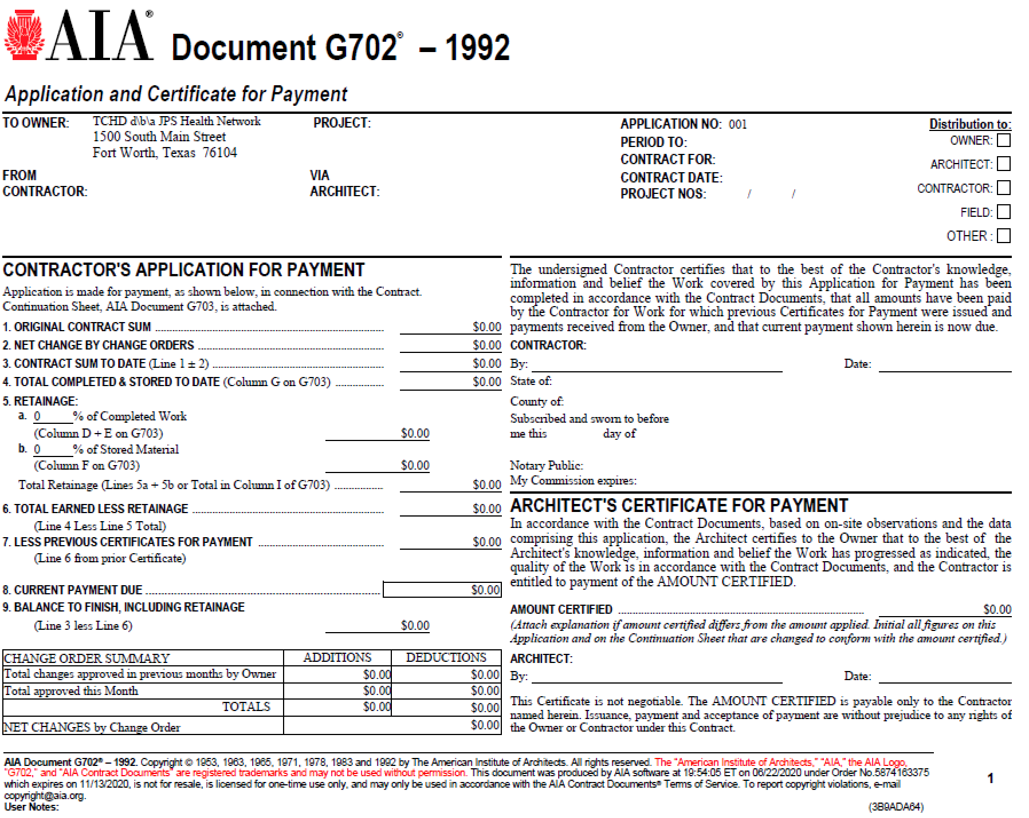

Exhibit J-4 - AIA G703 CONTINUATION SHEET

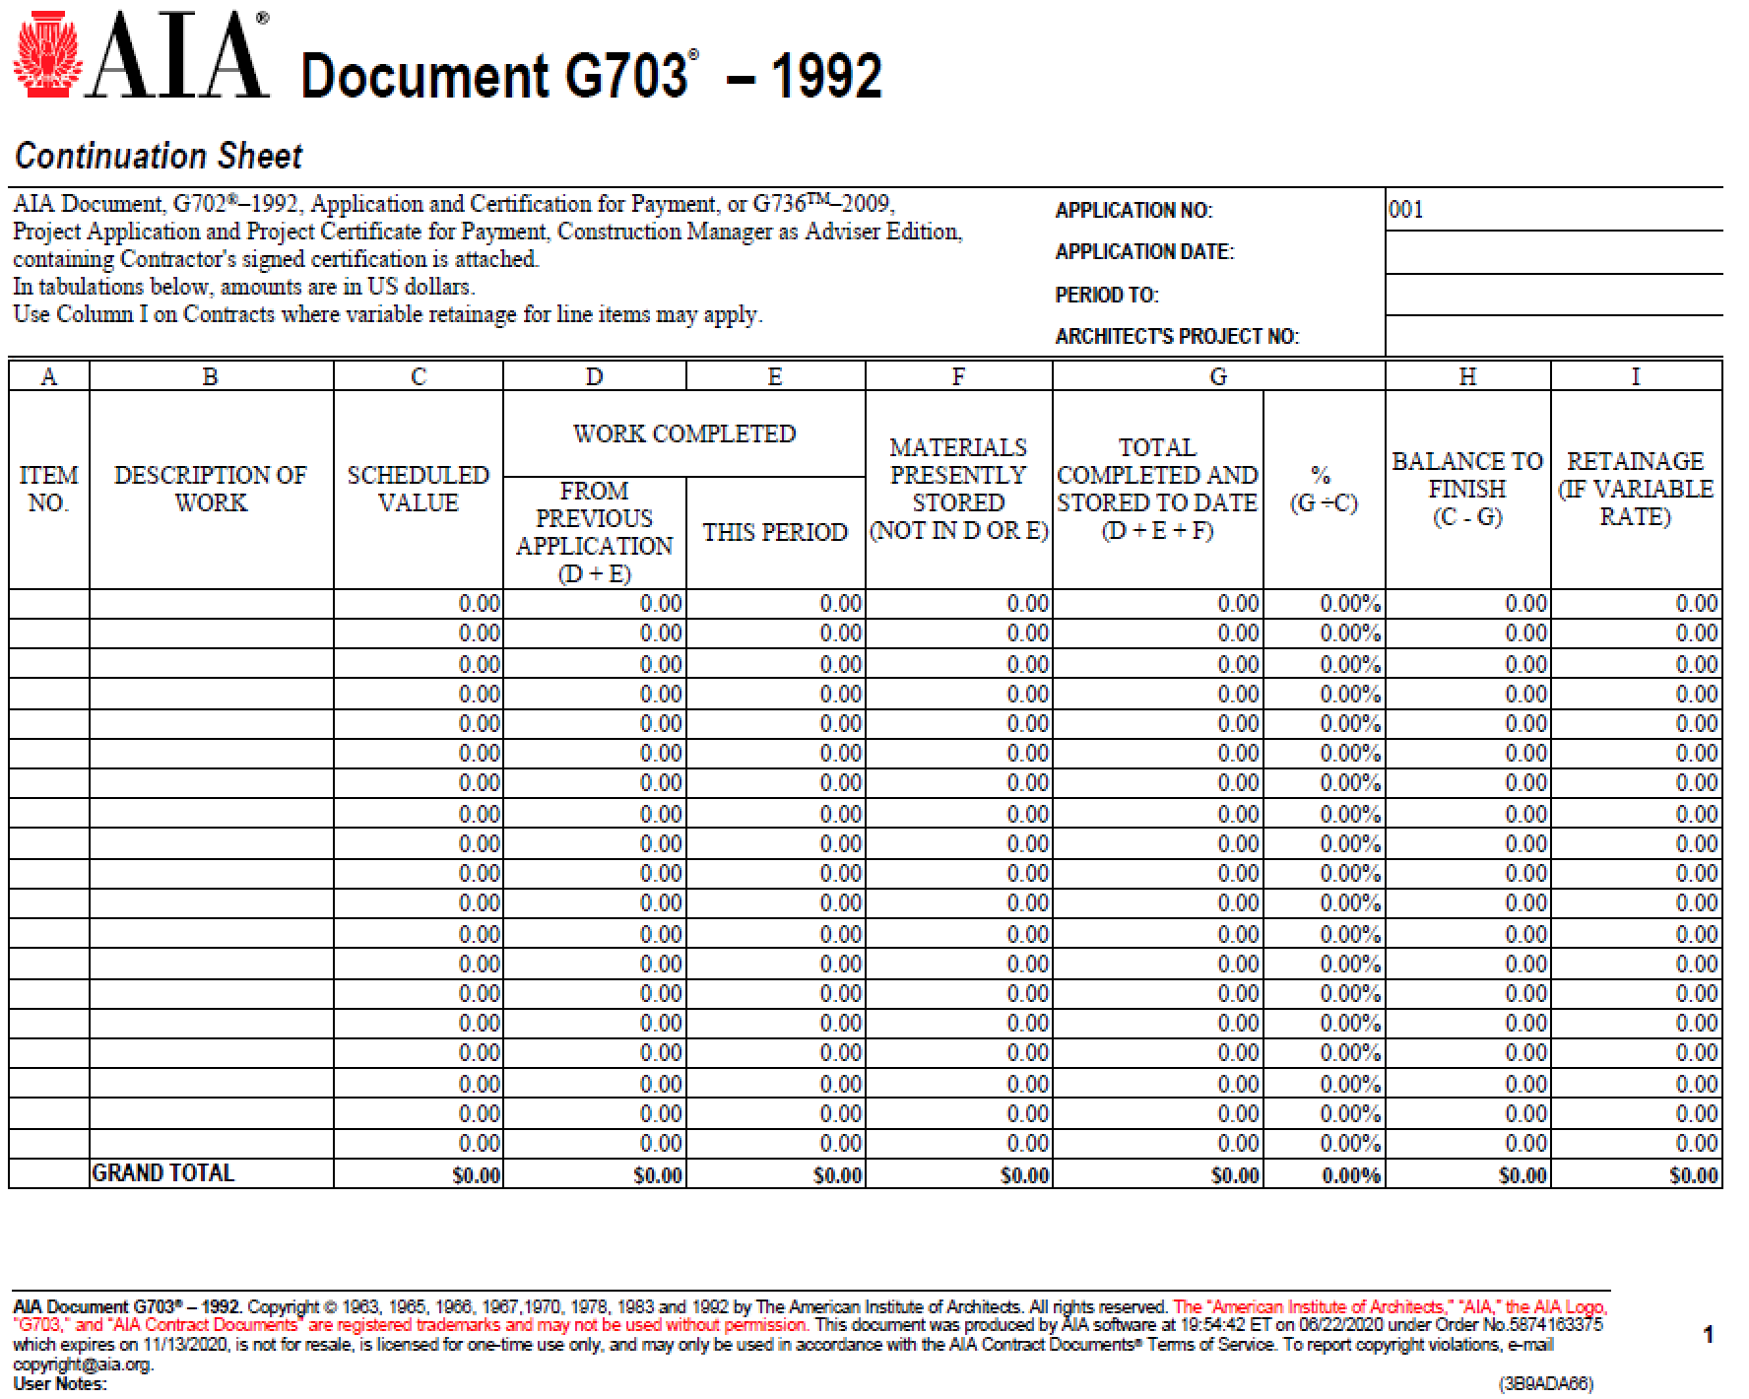

Exhibit J-5 – AIA G704 CERTIFICATE OF SUBSTANTIAL COMPLETION

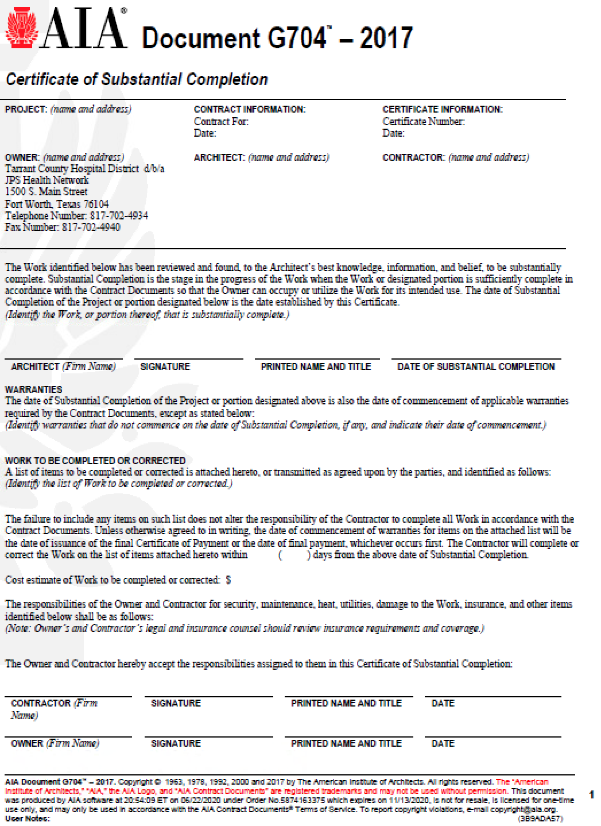

Exhibit J-6 – WAIVER AND RELEASE DOCUMENTS

EXHIBIT J-6A

CONDITIONAL WAIVER AND RELEASE ON PROGRESS PAYMENT

Project:

Job No.

On receipt by the signer of this document of a check from (maker of check) in the sum of $ payable to (payee or payees of check) and when the check has been properly endorsed and has been paid by the bank on which it is drawn, this document becomes effective to release any mechanic’s lien right, any right arising from a payment bond that complies with a state or federal statute, any common law payment bond right, any claim for payment, and any rights under any similar ordinance, rule, or statute related to claim or payment rights for persons in the signer’s position that the signer has on the property of (owner) located at (location) to the following extent: (job description).

This release covers a progress payment for all labor, services, equipment, or materials furnished to the property or to (person with whom signer contracted) as indicated in the attached statement(s) or progress payment request(s), except for unpaid retention, pending modifications and changes, or other items furnished.

Before any recipient of this document relies on this document, the recipient should verify evidence of payment to the signer.

The signer warrants that the signer has already paid or will use the funds received from this progress payment to promptly pay in full all of the signer’s laborers, subcontractors, materialmen, and suppliers for all work, materials, equipment, or services provided for or to the above referenced project in regard to the attached statement(s) or progress payment request(s).

Date:

(Company Name)

By: (Signature)

(Title)

EXHIBIT J-6B

NOTICE
This document waives rights unconditionally and states that you have been paid for giving up those rights. It is prohibited for a person to require you to sign this document if you have not been paid the payment amount set forth below. If you have not been paid, use a conditional release form.

UNCONDITIONAL WAIVER AND RELEASE ON PROGRESS PAYMENT
Project
Job No.

The signer of this document has been paid and has received a progress payment in the sum of $ for all labor, services, equipment, or materials furnished to the property or to (person with whom signer contracted) on the property of (owner) located at (location) to the following extent: (job description). The signer therefore waives and releases any mechanic’s lien right, any right arising from a payment bond that complies with a state or federal statute, any common law payment bond right, any claim for payment, and any rights under any similar ordinance, rule, or statute related to claim or payment rights for persons in the signer’s position that the signer has on the above referenced project to the following extent: ________________________ (job description).
This release covers a progress payment for all labor, services, equipment, or materials furnished to the property or to (person with whom signer contracted) as indicated in the attached statement(s) or progress payment request(s), except for unpaid retention, pending modifications and changes, or other items furnished.
The signer warrants that the signer has already paid or will use the funds received from this progress payment to promptly pay in full all of the signer’s laborers, subcontractors, materialmen, and suppliers for all work, materials, equipment, or services provided for or to the above referenced project in regard to the attached statement(s) or progress payment request(s).
Date:

(Company Name)

By: (Signature)

(Title)

EXHIBIT J-6C

CONDITIONAL WAIVER AND RELEASE ON FINAL PAYMENT

Project

Job No.

On receipt by the signer of this document of a check from (maker of check) in the sum of $ payable to (payee or payees of check) and when the check has been properly endorsed and has been paid by the bank on which it is drawn, this document becomes effective to release mechanic’s lien right, any right arising from a payment bond that complies with a state or federal statute, any common law payment bond right, any claim for payment, and any rights under any similar ordinance, rule, or statute related to claim or payment rights for persons in the signer’s position that the signer has on the property of (owner) located at (location) to the following extent: (job description).
This release covers the final payment to the signer for all labor, services, equipment, or materials furnished to the property or to (person with whom signer contracted).
Before any recipient of this document relies on this document, the recipient should verify evidence of payment to the signer.
The signer warrants that the signer has already paid or will use the funds received from this final payment to promptly pay in full all of the signer’s laborers, subcontractors, materialmen, and suppliers for all work, materials, equipment, or services provided for or to the above referenced project up to the date of this waiver and release.

Date:

(Company Name)

By: (Signature)

(Title)

EXHIBIT J-6D

NOTICE
This document waives rights unconditionally and states that you have been paid for giving up those rights. It is prohibited for a person to require you to sign this document if you have not been paid the payment amount set forth below. If you have not been paid, use a conditional release form.

UNCONDITIONAL WAIVER AND RELEASE ON FINAL PAYMENT
Project

Job No.

The signer of this document has been paid in full for all labor, services, equipment, or materials furnished to the property or to (person with whom signer contracted) on the property of (owner) located at (location) to the following extent: (job description). The signer therefore waives and releases any mechanic’s lien right, any right arising from a payment bond that complies with a state or federal statute, any common law payment bond right, any claim for payment, and any rights under any similar ordinance, rule, or statute related to claim or payment rights for persons in the signer’s position.
The signer warrants that the signer has already paid or will use the funds received from this final payment to promptly pay in full all of the signer’s laborers, subcontractors, materialmen, and suppliers for all work, materials, equipment, or services provided for or to the above referenced project up to the date of this waiver and release.

Date:

(Company Name)

By: (Signature)

(Title)

Exhibit J-7 – AIA G707 CONSENT OF SURETY TO FINAL PAYMENT

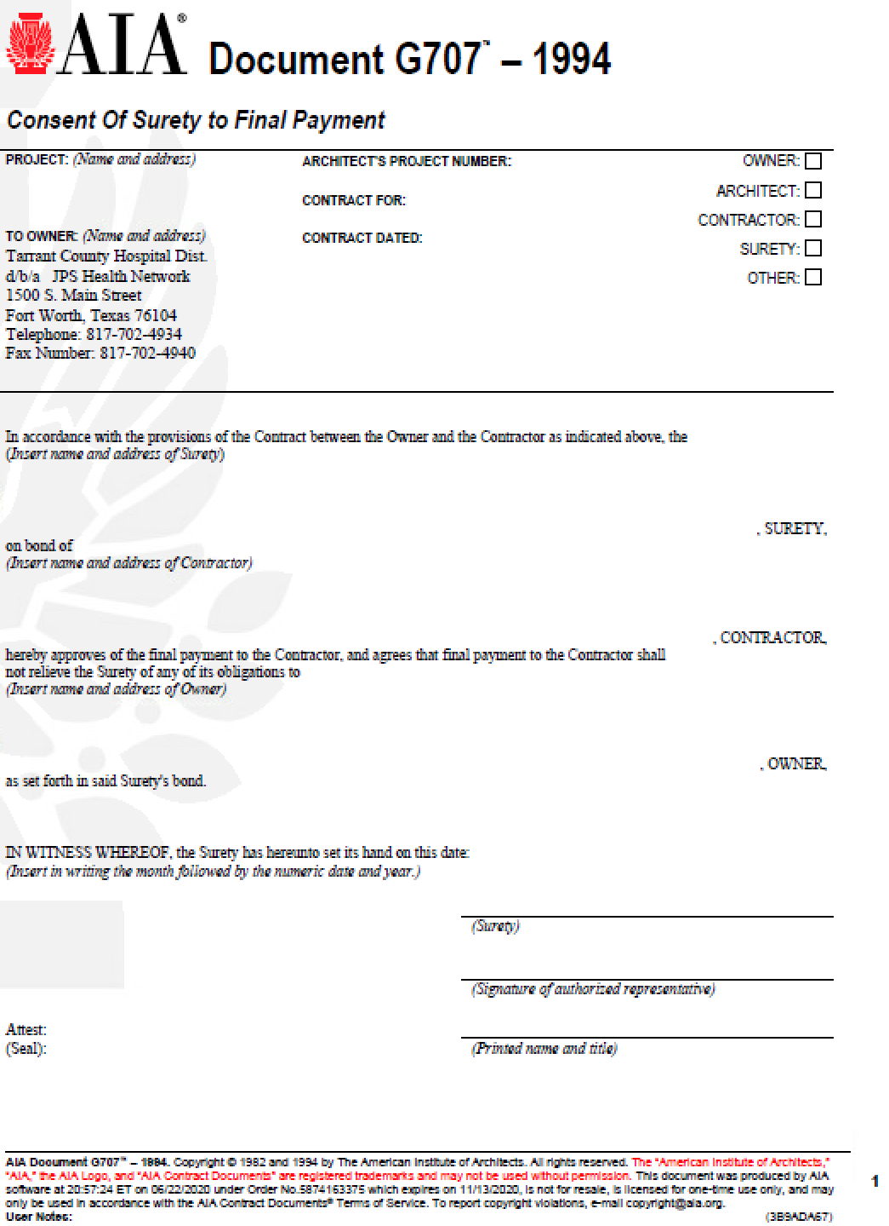

Exhibit J-8 – AIA G707A CONSENT OF SURETY TO REDUCTION IN RETAINAGE

